**Lab 5: Encoding and Decoding using DCode**

**R. Harini**

**18BCE1010**

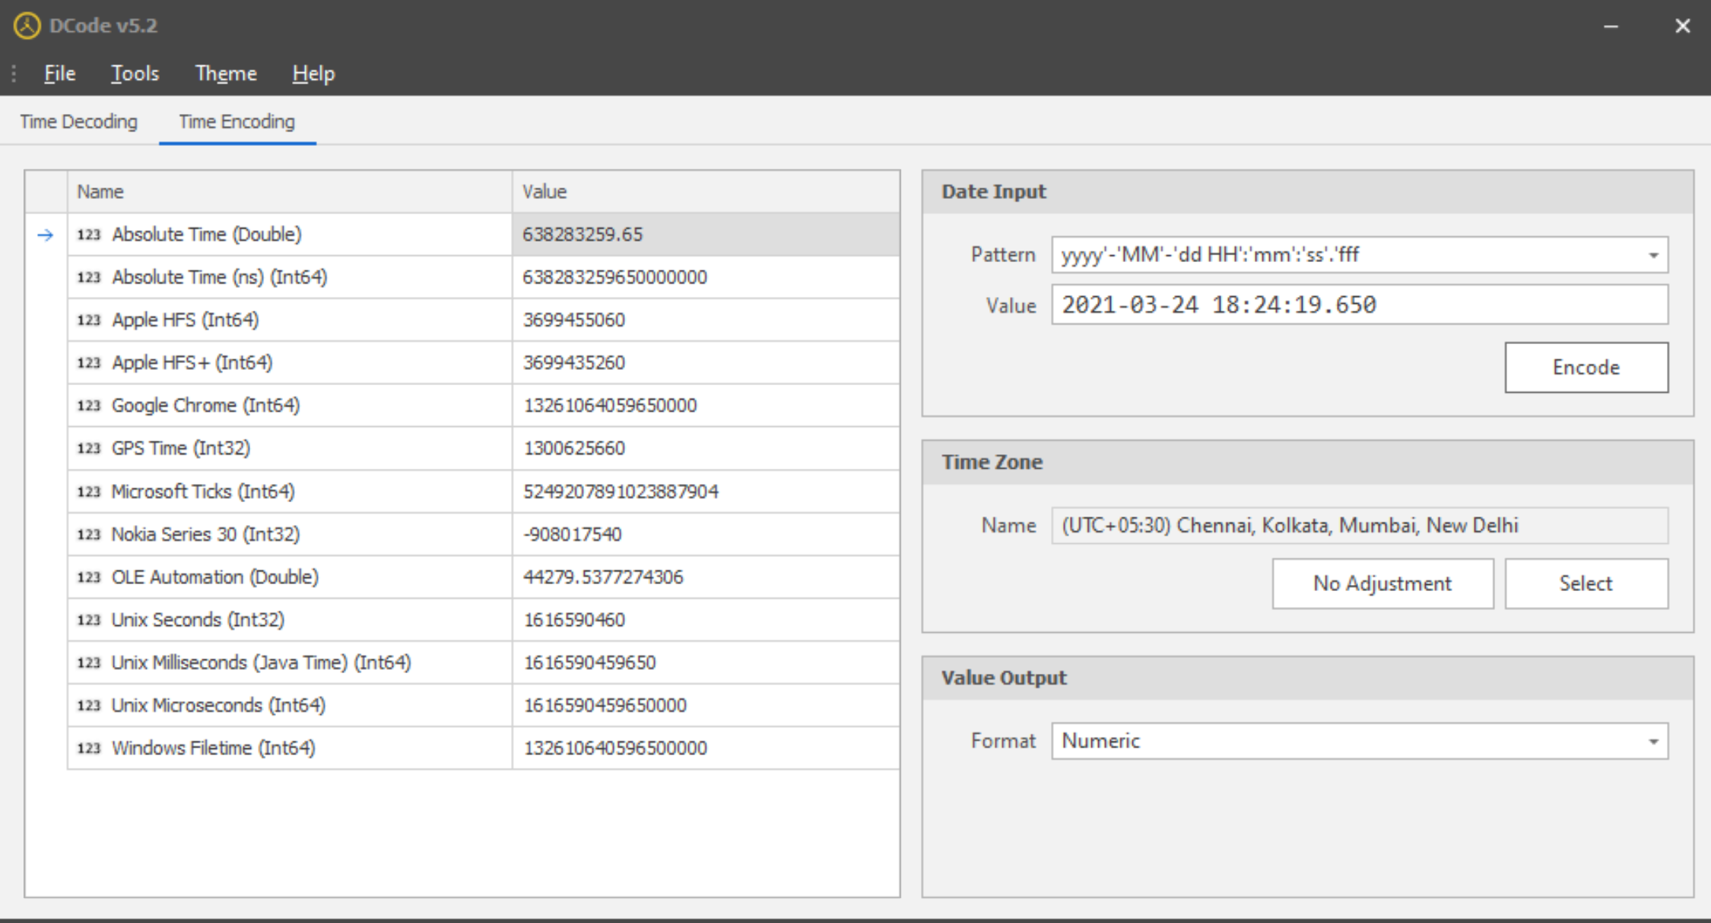

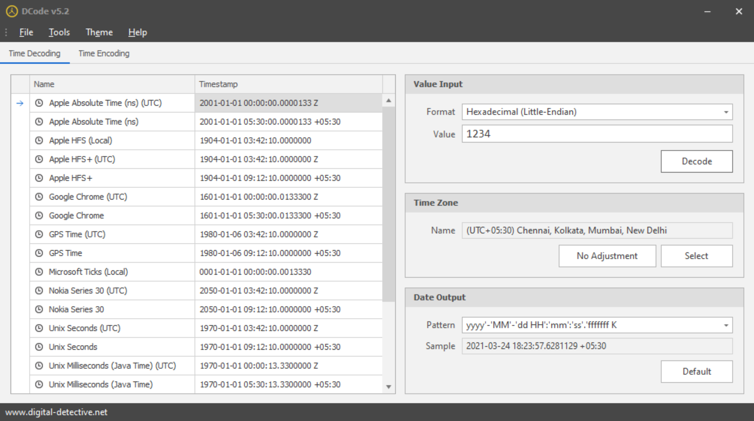

**Using String.exe**

**Procedure:**

Open cmd

Navigate to the path with the .docx file

Type **strings <filename>.docx**

**Output:**

